How to Calculate Windchill

Wind chill is the apparent temperature felt on the exposed human body owing to the combination of temperature and wind speed.

The wind chill factor describes what happens to a body when it is cold and windy outside.

Formula to calculate windchill.

Wind chill formula in English units of measurement

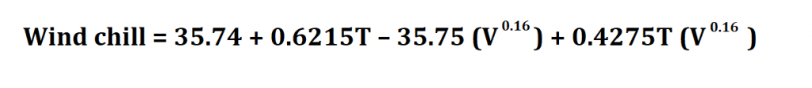

T = Temperature in degrees Fahrenheit

V = Wind velocity in miles per hour

Wind chill formula in metric units.

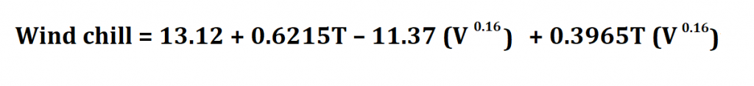

T = Temperature in degrees Celsius

V = Wind velocity in kilometers per hour